# Linux nginx VUE部署

## 1.安装nginx

### 下载niginx依赖

yum install gcc  
yum install pcre-devel  
yum install zlib zlib-devel  
yum install openssl openssl-devel

### 下载nginx的tar包

//创建文件夹  
cd /iflytek/sgy/service  
mkdir nginx  
cd nginx

### 下载tar包

Wget http://nginx.org/download/nginx-1.13.7.tar.gz  
//解压  
tar -xvf nginx-1.13.7.tar.gz

### 安装nginx

//进入nginx目录  
cd nginx  
//执行命令  
./configure   
//执行make命令  
make  
//执行make install命令  
make install

### 添加防火墙

//添加80防火墙  
iptables -A INPUT -p tcp --dport 80 -j ACCEPT   
//保存  
service iptables save   
//重启  
systemctl restart iptables.service   
//查看防火墙配置  
iptables -L -n

### nginx启动

//启动命令  
/usr/local/nginx/sbin/nginx -c /usr/local/nginx/conf/nginx.conf

浏览器输入ip地址就能看到nginx成功启动页面

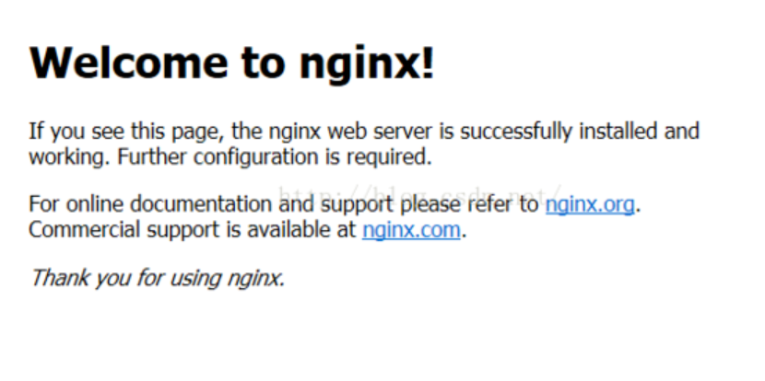

## 2.上传VUE的disk文件

### 创建文件夹

cd /iflytek/sgy/server/  
//创建文件夹  
mkdir zwtjfx-web  
cd zwtjfx-web   
//上传disk.zip文件到zwtjfx-web 解压  
unzip disk.zip  
//删除 disk.zip  
rm -rf disk.zip  
//目录授权  
chmod u+x *

web目录结构 /iflytek/sgy/server/zwtjfx-web

## 3.配置nginx

//进入nginx目录  
cd /iflytek/sgy/server/nigin/conf  
//编辑nginx.conf  
vim nginx.conf

在nginx.conf server中添加一下配置

//监听端口为80  
listen 80;  
//监听服务器  
server_name 10.54.19.71;  
 //前端路径  
 root /iflytek/sgy/server/zwtjfx-web;  
 index index.html;  
 charset koi8-r;  
  
 access_log logs/host.access.log main  
 //请求 /zwsjfx的接口  
 location /zwsjfx {  
 proxy_redirect off;  
 proxy_set_header Host $host;  
 proxy_set_header X-Real-IP $remote_addr;  
 proxy_set_header X-Forwarded-For $proxy_add_x_forwarded_for;  
 //请求 /zwsjfx这个后缀的 都会转发到后端tomcat  
 proxy_pass http://127.0.0.1:8085;}  
 //请求前端  
 location /#/hzdsj/ {  
 root /iflytek/sgy/server/zwtjfx-web/zwtjfx-web;  
 try_files $uri $uri/ /index.html last;  
 index index.html;  
 }   
 location / {  
 root /iflytek/sgy/server/zwtjfx-web;  
 proxy_pass http://127.0.0.1:8085;  
 try_files $uri $uri/ /index.html last;  
 index index.html;  
 }

### 重启nginx服务

/usr/local/nginx/sbin/nginx -t -c /usr/local/nginx/conf/nginx.conf  
cd /iflytek/sgy/server/nginx/sbin/  
./nginx -s reload

# 结束

#### 如文档有理解出错的地方，请指出，yfzhang18@iflytek 谢谢。